SPECIFICATION FOR REDI-SCAPES® 115 AND 140 SERIES WALL SYSTEM

PART 1: GENERAL

1.1 Scope
Work includes furnishing and installing concrete retaining wall units to the lines and grades designated on the construction drawings and as specified herein.

1.2 Reference Standards
ASTM C94 Ready-Mixed Concrete
ASTM C1372 Segmental Retaining Wall Units

1.3 Delivery, Storage, and Handling
A. Contractor shall check the materials upon delivery to assure proper material has been received.
B. Contractor shall prevent excessive mud, wet cement and like materials from coming in contact with the SRW units.
C. Contractor shall protect the materials from damage. Damaged material shall not be incorporated in the project.

PART 2: MATERIALS

2.1 Wall Units
A. Wall units shall be Redi-Scapes® as produced by a licensed manufacturer.
B. Wall units shall be made with Ready-Mixed concrete in accordance with ASTM C94, latest revision, and per the following chart:
Climate | Air Content | 28 Day Compressive Strength, psi | Slump*
Negligible | 1½%-4½% | 4000 | 5” ±1 ½”
Moderate | 3%-6% | 4000 | 5” ±1 ½”
Severe | 4½%-7½% | 4000 | 5” ±1 ½”

*Higher slumps are allowed if achieved by use of appropriate admixtures.

Notwithstanding anything stated above, all material used in the wall units must meet applicable ASTM and local requirements for exterior concrete.
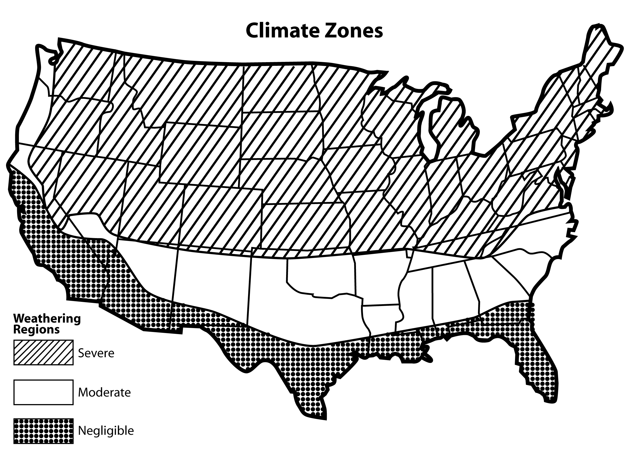
C. Exterior block dimensions shall be uniform and consistent. Maximum dimensional deviations shall be 1/8” excluding the architectural surface.
D. Exposed face shall be finished as specified. Other surfaces to be smooth form type.

2.2 Leveling Pad and Free Draining Backfill
A. Leveling pad shall be crushed stone. See detail sheet defining Leveling Pad options for drain placement in the bottom of the foundation leveling pad.
B. Free Draining Backfill material shall be washed stone and shall be placed to a minimum of 1’ width behind the back of the wall and shall extend vertically from the Leveling Pad to an elevation 4” below the top of wall.
C. Backfill material shall be approved by the geotechnical engineer. Site excavated soils may be used if approved unless otherwise specified in the drawings. Unsuitable soils with a PL>6, organic soils and frost susceptible soils shall not be used within a 1 to 1 influence area.
D. Non-woven geotextile cloth shall be placed between the Free Draining Backfill and retained soil if required.
E. Where additional fill is needed, Contractor shall submit sample and specifications to the Engineer for approval.
2.3 Drainage
A. Internal and external drainage shall be evaluated by the Professional Engineer who is responsible for the final wall design.

2.4 Geogrid Connection
A. Cores in the block shall be filled with #57 crushed stone consolidated by hand tamping with a rod. Place geogrid between courses of block full width (9”) of the formed contact surface. Place the next block course and fill cores with consolidated #57 crushed stone.

PART 3: CONSTRUCTION OF WALL SYSTEM

3.1 Excavation
A. Contractor shall excavate to the lines and grades shown on the construction drawings.

3.2 Foundation Soil Preparation
A. Native foundation soil shall be compacted to 95% of standard proctor or 90% of modified proctor prior to placement of the Leveling Pad material.
B. In-situ foundation soil shall be examined by the Engineer to ensure that the actual foundation soil strength meets or exceeds assumed design strength. Soil not meeting the required strength shall be removed and replaced with acceptable, compacted material.

3.3 Leveling Pad Placement
A. Leveling Pad shall be placed as shown on the construction drawings.
B. Leveling Pad shall be placed on undisturbed native soils or suitable replacements fills.
C. Leveling Pad shall be compacted to 95% of standard proctor or 90% of modified proctor to ensure a level, hard surface on which to place the first course blocks. Pad shall be constructed to the proper elevation to ensure the final elevation shown on the plans.
D. Leveling Pad shall have a 6 inch minimum depth for walls under 8 feet in height and a 12 inch minimum depth for walls 8 feet and taller. Pad dimensions shall extend beyond the blocks in all directions to a distance at least equal to the depth of the pad or as designed by Engineer.
E. For steps and pavers, a minimum of 1” - 1 ½” of free draining sand shall be screeded smooth to act as a placement bed for the steps or pavers.

3.4 Unit Installation
A. The first course of wall units shall be placed on the prepared Leveling Pad with the aesthetic surface facing out and the front edges tight together. All units shall be checked for level and alignment as they are placed.
B. Ensure that units are in full contact with Leveling Pad. Proper care shall be taken to develop straight lines and smooth curves on base course as per wall layout.
C. The backfill in front and back of entire base row shall be placed and compacted to firmly lock them in place. Check all units again for level and alignment. All excess material shall be swept from top of units.
D. Install next course of wall units on top of base row. Position blocks to be offset from seams of blocks below. Blocks shall be placed fully forward so knob and groove are engaged. Check each block for proper alignment and level. Backfill to 12 inch width behind block with Free Draining Backfill. Spread backfill in uniform lifts not exceeding 9 inches. Employ methods using lightweight compaction equipment that will not disrupt the stability or batter of the wall. Hand-operated plate compaction equipment shall be used around the block and within 3 feet of the wall to achieve consolidation. Compact backfill to 95% of standard proctor (ASTM D 698, AASHTO T-99) density within 2% of its optimum moisture content.
E. Install each subsequent course in like manner. Repeat procedure to the extent of wall height.
F. Allowable construction tolerance at the wall face is 2 degrees vertically and 1 inch in 10 feet horizontally.
G. All walls shall be installed in accordance with local building codes and requirements.

3.5 Geogrid Installation
A. See Wall Installation instructions.

PART 4: AVAILABILITY
Redi-Scapes®
05481 South US-31,
Charlevoix, MI 49720
1-866-222-8400
www.redi-scapes.com

